FBSA Committee Meeting Agenda
Thursday 12th Sept 2024, 8.00p.m - The Angel
Apologies:
 | Item |  | Notes / What we need to achieve | Who
1. | Welcome |  | • Welcome, Introductions & Apologies | AH
2. | Minutes Agreed |  | - Review previous meeting minutes - 8/5/24  - Agree outstanding actions | FF/LA
3. | Events Review & Financial Update |  | - Total raised 23/24 - £23, 610  - FBSA current financial standing | MF/DW
4 | School Spending Requests | • | New School requests & update | DW
5. | 2024 Scheduled Events |  | - Penny wars - to be launched 1st Oct  - Barn Dance 5th Oct - promote ticket sales - info from MF  - Michaelmas 28th Sept - Sycamore?  - Spooktacular Disco - 2nd Nov  - Fireworks 8th Nov  - Xmas Disco - 13th Dec  - Xmas cards | EG/EGM/  AH/DW/ MF
6. | Cakes Sales/Bag2School/  Uniform Sales/  FBFC |  | - Cake sales - dates below to be shared with classes  - Bags2School - Fri 17th Jan -Stick with Jan/Jun collections?  - Introduce Uniform sales team -Next sale?  - FBFC update | AH/EGM/ FG/CA

7. | Fireworks Planning | - Feedback from last year……  - 18:30 Fire time Booked & confirmed (£4100 - £400 increase)  - Tickets - on sale 7/10  - Paramedic Booked (£245)  - Fireworks sponsorship next year  - Food stalls booked(Pizza, Dutch pancakes, ice cream)  - Games - locked box/ name a teddy, lollipop game  - Stalls  - Raffle prizes - re-launch raffle team  - Bar Licence - LA/FF • Sponsors?  - Volunteer Spreadsheet  - Traffic Control | EGM/AH/  DW
8. | Next Meeting | - AGM date - Thurs 17th Oct @ School Hall  - Next meeting - Fireworks (before half term) | EGM
9. | AOB | Hoodies  Future events:  Long Ashton Cafe - 1st Feb (volunteers) | ALL

Annual Calendar of Events and Dates for your Diary - TBC
(Fri 22nd?) Sept - Uniform Sale
Sat 2nd Nov - SPooktacular Disco
Fri 8th Nov - Fireworks
(Fri 1st? Dec - Uniform & Xmas ouDit Sale
Fri 13th Dec - Xmas Disco
Fri 17th Jan - Bags2School
Fri ? Feb - Uniform & WBD/Fancy Dress Sale
Sat 1st Feb - Long Ashton Cafe
Sat 10th Feb - Bingo night (formerly quiz night)
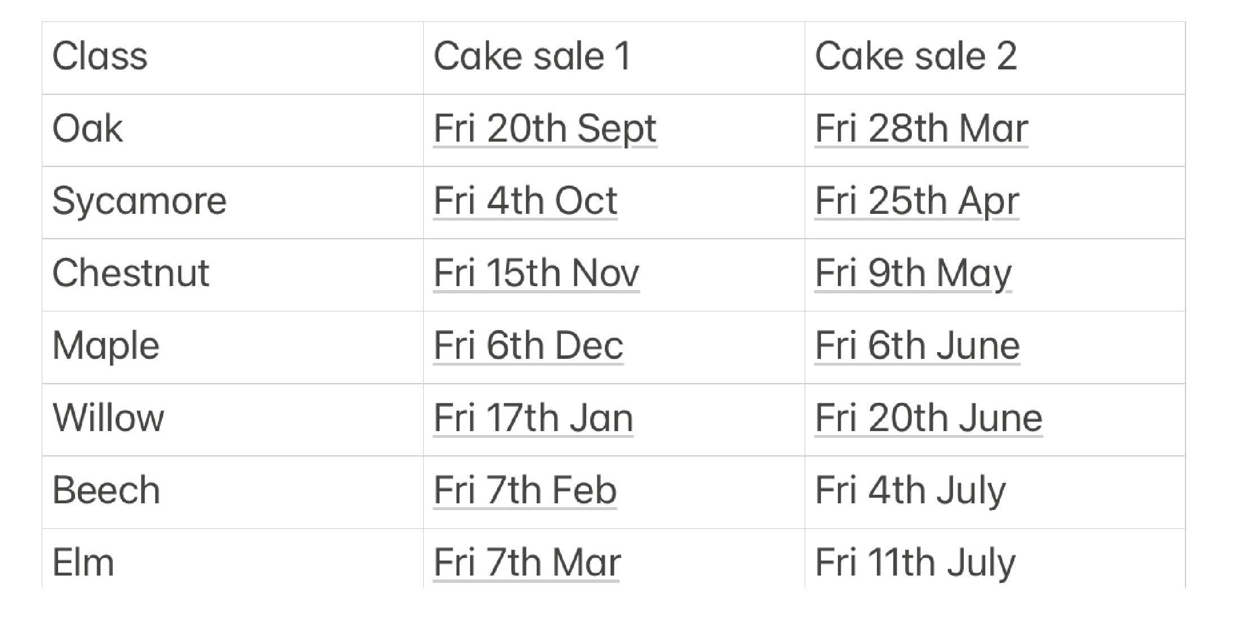
Weds 2nd Apr - "Break The Rules Day"
Thurs 3rd Apr Easter Egg hunt TBC
(Fri 21st April) - Uniform Sale
Wed 21st May– Summer event/fundraiser
June - Bags2School - TBC
June) - Summer Event - TBC
Tues 22rd July - Party in the Playground (aZer sch) TBC

Cake Sale Dates

