
FBSA Committee Meeting
Date: 12th September 2024
Time: 8pm
Location: The Angel
Attendees: Abi Henderson (AH), Emily Gazey-Mitchell (EGM), Steve Lung (SL), Fiona Furzeland (FF), Laura Aitken (LA), Donna Williams (DW), Roz Rendall (RR), Charli Awde (CA),Sarah Ballisat (BB), Felicity Gibbs (FG), Meg Carr (MC), Freya Geall (FG), Vic Coyne (VC), Emma Hulmes (EH) , Becky Gibbs (BG), Delia Wakeford (DWf), Steph Wolff (SW), Donna Williams (DW), Steve Lunch (SL)
Apologies: Emma Ghent (EG), Mark Francis (MF), Lisa Anthoney (LA), Adam Crooks (AC), Jennifer Chard (JC), Ben Baillisat (BB), Hannh Bodkin (HB), Ally Ng (AN), Posy Smetham (PS), Sarah Nicholls (SN)
Item | Description of Discussion | Action
- Welcome
- Minutes Agreed | Carry over from last meeting: KS2 Triathlon entries for fundraiser | Meg Carr to notify FBSA when booking opens
- Financial Update | Total raised 23/24 - £23, 610  FBSA current financial standing detailed in appendix  Discussed the tarmac track – A Crooks obtaining quotes  Discussed possible ringfenced Oakley Park development  We discussed the treats / treats budget to be called ‘enrichment | A Crooks to feedback  Natasha to feedback to Mr Lung  MF to adjust financial plan 24/25
- School Spending Requests | DW confirmed some changes the school invoicing process:  - The school will invoice FBSA for the total school trips / treats budgets at the start of the year  - Changes to how cake-sale money will be managed  - APPROVED - Request for increases to class enrichment to £850 per class (travel costs increased to £450 pa + class resources to £400pa) APPROVED  [The school will invoice this up front and provide a plan for how it will be spent for each class at the next meeting]  - APPROVED - Lifeskills – increase from £216 up to £600 include hiring a trainer for the day  - Chickens – have we allocated enough in the 24/25 budget o cover feed / maintenance costs? Currently £280pa  - Mr Lung flagged the need for new football goals and will provide a quote for approval | SL/DW will provide feedback on enrichment plans per class for the FBSA funds  SL/DW will provide a revised estimate for chickens maintenance  SL/DW to provide quote for goals
- Upcoming events | - Penny wars - to be launched 1st Oct  - Barn Dance 5th Oct - promote ticket sales - info from MF  - Michaelmas 28th Sept – Sycamore to go to the Christmas Market  - Spooktacular Disco - 2nd Nov  - Fireworks - 8th Nov  Volunteers will be needed  - Xmas Disco - 13th Dec  - Xmas cards
5A. Fireworks | - Increase in ticket costs to +£1 on 2024 prices  - Tickets - on sale 7/10  - Paramedic Booked (£245)  - Fireworks sponsorship next year  - Food:  - Some stalls booked – no food to be run in the school kitchen this year  - Games – (Becky & Meg to run kids tombola, Roz on crafts, Lucy and facepainting)  - Raffle prizes (Team - Roz + Steph)  - Stalls TBC  - Bar Licence - LA/FF  - Sponsors?  - Volunteer Spreadsheet  - Traffic Control
- Cake sale/bags 2 school/uniform sales/football updates | - Cake sales - dates below to be shared with classes, in appendix  - Bags2School - Fri 17th Jan (and again in June, date TBC)  - Introduce Uniform sales team -Felicity & Charli  - FBFC update
- Additional fundraising | - Roller disco confirmed Oct 18th  - Easyfundraising to be sent out on next newsletter  - Asda shops now can donate 0.05% cashback automatically if you do a shop in next 80 days
- Events Further Ahead | - Sat 1st Feb – long Ashton café takeover of the café for FBSA fundraising  - Annual summer fundraiser: Discussed possibility of a climbing wall / inflatable course  - EOY summer party in the playground
- Next Meeting | - Dates confirmed for the year  - Thurs 17th Oct – AGM  - Mon 18th Nov  - Thurs 16th Jan  - Mon 17th March  - Thurs 8th May
- AOB | - Hoodies: Agreed that these will not be funded by FBSA  - Vic asked if the hoodies could be sold/worn earlier in the year

Latest financial standing:
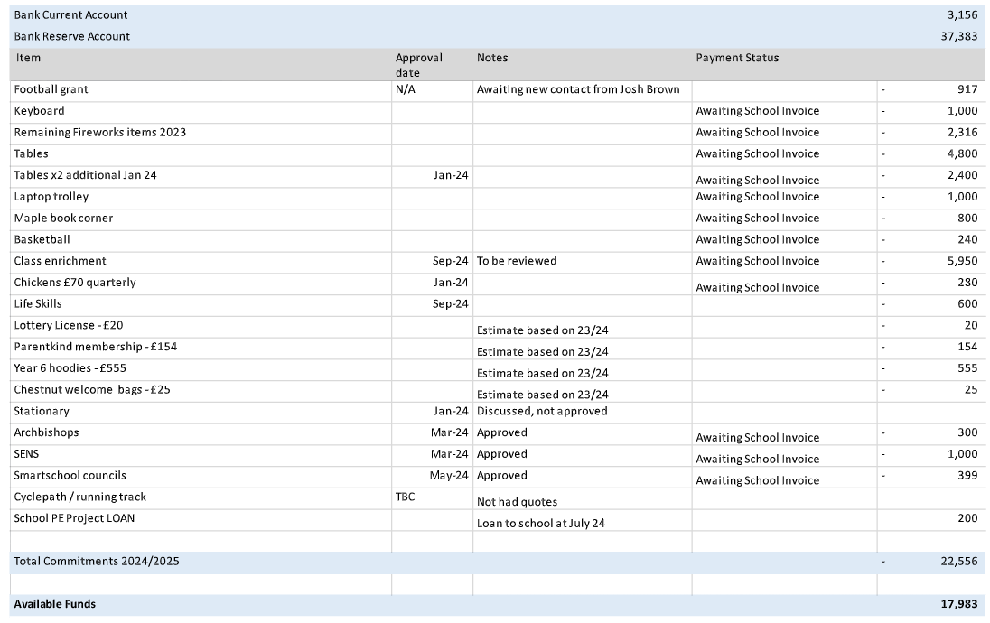

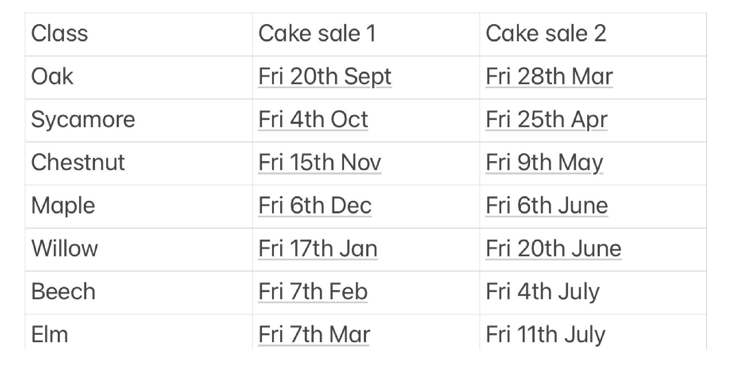
Cake sale dates:

