

LSP Computing Plans and Key Information
2021-2022


Contents
Intent
Curriculum Map Overview Long Term Plan
Teach Computing – key information
- Teaching order
- Learning graphs
- Online safety
- Progression and taxonomy
- Resources (software and hardware)
- National Curriculum coverage
Overview for all years 1 - 6

Intent

Computing LTP | Year 1 | Year 2 | Year 3 | Year 4 | Year 5 | Year 6
Autumn | Computing systems  and networks Technology around us (1.1)*  Creating media A Digital painting  (1.2) | Computing systems  and networks  Information technology  around us  (2.1)*  Creating media A  Digital photography  (2.2) | Computing systems  and networks  Connecting  computers  (3.1)  Creating media A  Stop-frame  animation  (3.2) | Computing systems  and networks  The  internet  (4.1)  Creating media A  Audio  editing  (4.2) | Computing systems  and networks  Sharing  information  (5.1)  Creating media A  Video  editing  (5.2) | Computing systems  and networks  Internet  communication  (6.1)  Creating media A  Webpage  creation  (6.2)
Spring | Programming A Moving a robot  (1.3)  Data and information Grouping data  (1.4) | Programming A Robot algorithms  (2.3)  Data and information  Pictograms  (2.4) | Programming A  Sequencing  sounds  (3.3)  Data and information  Branching  databases  (3.4) | Programming A  Repetition  in shapes  (4.3)  Data and information  Data  logging  (4.4) | Programming A  Selection in  physical computing  (5.3)  Data and information  Flat-file  databases  (5.4) | Programming A  Variables  in games  (6.3)  Data and information  Introduction to  spreadsheets  (6.4)
Summer | Creating media B Digital writing  (1.5)  Programming B Programming  animations  (1.6) | Creating media B Making music  (2.5)  Programming B  Programming quizzes  (2.6) | Creating media B  Desktop  publishing  (3.5)  Programming B  Events and actions  in programs  (3.6) | Creating media B  Photo  editing  (4.5)  Programming B  Repetition  in games  (4.6) | Creating media B  Vector  drawing  (5.5)  Programming B  Selection  in quizzes  (5.6) | Creating media B  3D  modelling  (6.5)  Programming B  Sensing  (6.6)
*Networks are not part of the key stage 1 national curriculum for computing but the title is used as a strand across primary.

Teach Computing – Key information
The LSP computing curriculum is based on the Teach Computing. Each year group has 6 units with 6 lessons per unit which have a spiral progression and build on prior learning and experiences of concept and skills.
Teaching order: The order in which to teach units within a school year is not prescribed, other than for the two ‘Programming’ units for each year group, which build on each other. It is recommended that the ‘Programming’ and ‘Creating media’ units be revisited in two different terms within the school year, so that the concepts and skills can be revisited and consolidated. Otherwise, schools can choose the order in which they teach the units, based on the needs of their pupils and other topics or events that are happening throughout the school year, to make use of cross-curricular links wherever possible.

Learning graphs are provided as part of each unit and demonstrate progression through concepts and skills. In order to learn some of those concepts and skills, pupils need prior knowledge of others, so the learning graphs show which concepts and skills need to be taught first and which could be taught at a different time. In each year group, there are two ‘Programming’ units of work, but only one ‘Programming’ learning graph. The second ‘Programming’ unit builds on the content that was taught in the first ‘Programming’ unit so closely that there is no specific divide where one ends and the other begins.

Online safety: The unit overviews for each unit show the links between the content of the lessons and the national curriculum and Education for a Connected World framework (ncce.io/efacw). These references have been provided to show where aspects relating to online safety, or digital citizenship, are covered within the Teach Computing Curriculum. Not all of the objectives in the Education for a Connected World framework are covered in the Teach Computing Curriculum, as some are better suited to personal, social, health, and economic (PSHE) education; spiritual, moral, social, and cultural (SMSC) development; and citizenship. However, the coverage required for the computing national curriculum is provided. Schools should decide for themselves how they will ensure that online safety is being managed effectively in their setting, as the scope of this is much wider than just curriculum content.

Progression across key stages: All learning objectives have been mapped to the National Centre for Computing Education’s taxonomy of ten strands, which ensures that units build on each other from one key stage to the next.
Teach Computing Taxonomy
Abbreviation | Strand | Description
NW | Networks | Understand how networks can be used to retrieve and share information, and how they come with associated risks
CM | Creating Media | Select and create a range of media including text, images, sounds, and video
DI | Data & Information | Understand how data is stored, organised, and used to represent real-world artefacts and scenarios
DD | Design & Development | Understand the activities involved in planning, creating, and evaluating computing artefacts
CS | Computing Systems | Understand what a computer is, and how its constituent parts function together as a whole
IT | Impact of Technology | Understand how individuals, systems, and society as a whole interact with computer systems
AL | Algorithms | Be able to comprehend, design, create, and evaluate algorithms
PG | Programming | Create software to allow computers to solve problems
ET | Effective Use of tools | Use software tools to support computing work
SS | Safety & Security | Understand risks when using technology, and how to protect individuals and systems

Within the Teach Computing Curriculum, every year group learns through units within the same four themes, which combine the ten strands of the National Centre for Computing Education’s taxonomy (see table below). This approach allows us to use the spiral curriculum approach.
Primary Themes | Computing systems  and networks | Programming | Data and information | Creating media
Taxonomy Strands | - Computer systems  - Computer networks | - Programming  - Algorithms  - Design and development | - Data and information | - Creating media  - Design and development
Taxonomy Strands | Effective use of tools
Taxonomy Strands | Impact of technology
Taxonomy Strands | Safety and security

Software and hardware resources: Computing is intrinsically linked to technology and therefore requires that pupils experience and use a range of digital tools and devices. To make the units of work more accessible to pupils and teachers, the materials include screenshots, videos, and instructions, and these are based on the tools listed in the table below. The lists below should not be seen as an explicit requirement for schools. Schools may choose to use alternative tools that offer the same features as described in the units. All of the learning objectives can be met with alternative hardware and software, as the learning objectives are not designed to be tool-specific.
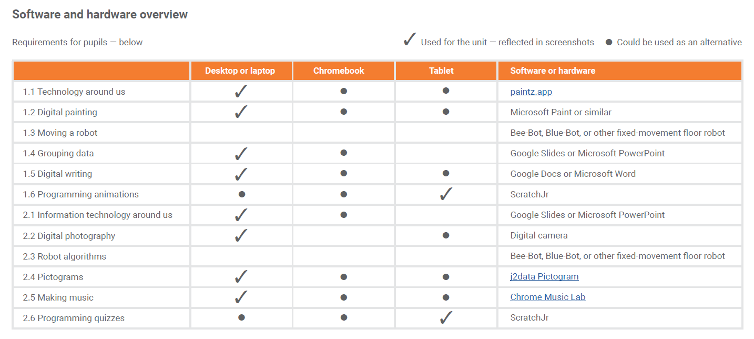
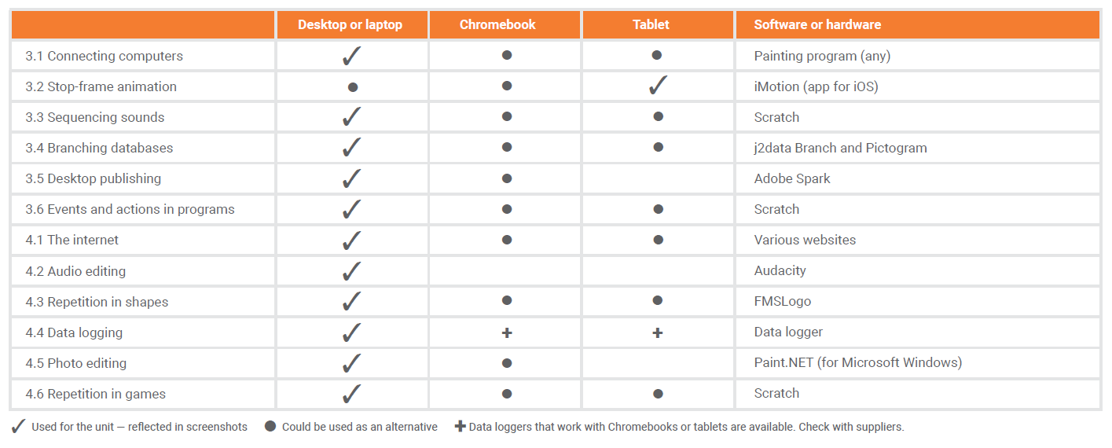
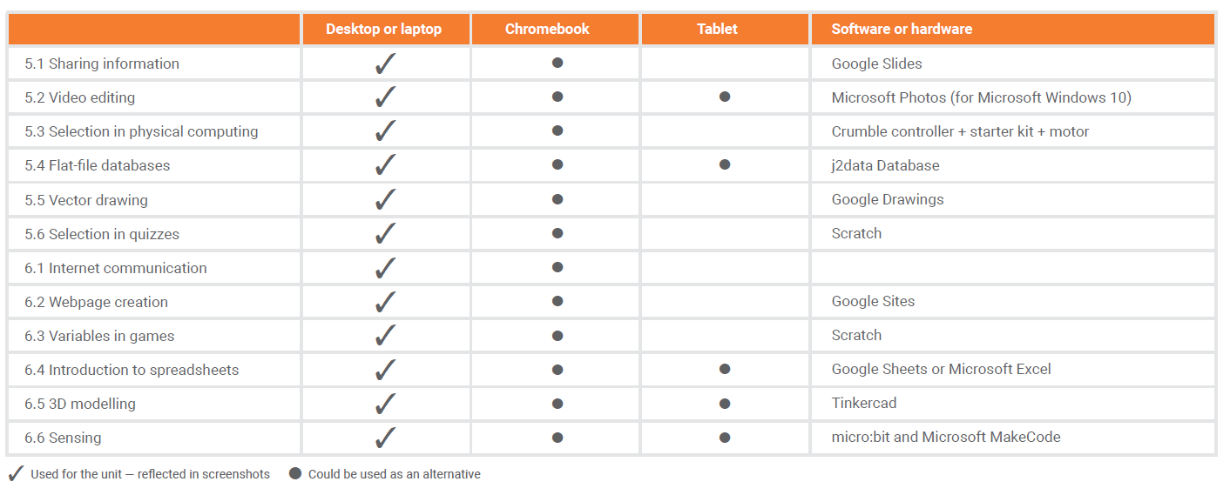
*Networks are not part of the key stage 1 national curriculum for computing but the title is used as a strand across primary.



