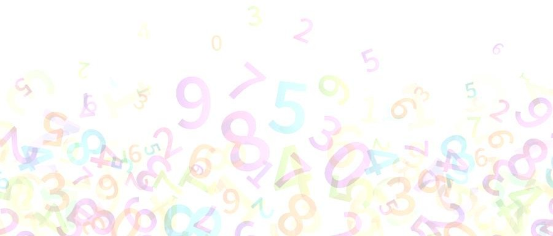





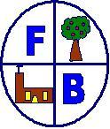

This policy has been largely adapted from the White Rose Maths Hub Calculation Policy with further material added.
November 2022



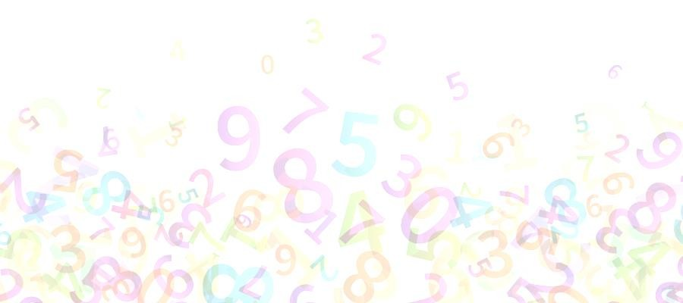
Aims of the Calculation Policy

- Outline appropriate methods to use to teach clarity and understanding in addition, subtraction, multiplication and division across the primary phase
- Clarify progression in mathematics across from EYFS to Key Stage 1 and Key Stage 2
- Ensure that children learn with understanding using the concrete, pictorial and abstract methods shown, and not just through procedural methods to simply be remembered
- Enable pupils to show their understanding using a variety of methods and explain the reasoning behind their findings
The Aims of the Early Years Foundation Stage (EYFS)

The statutory framework for the Early Years Foundation Stage in mathematics aims to ensure that all pupils:

- Develop a strong grounding in number so that all children develop the necessary building blocks to excel mathematically.
- Children are able to count confidently, develop a deep understanding of the numbers to 10, the relationships between them and the patterns within those numbers.
- Are provided with frequent and varied opportunities to build and apply their understanding - such as using manipulatives, including small pebbles and ten-frames for organising counting
- will develop a secure base of knowledge and vocabulary from which mastery of mathematics is built. In addition, it is important that the curriculum includes rich opportunities for children to develop their spatial reasoning skills across all areas of mathematics including shape, space and measures.
- develop positive attitudes and interests in mathematics, look for patterns and relationships, spot connections, ‘have a go’, talk to adults and peers about what they notice and not be afraid to make mistakes.
The Aims of the Curriculum

The national curriculum for mathematics aims to ensure that all pupils:

- Become fluent in the fundamentals of mathematics, including through varied and frequent practice with increasingly complex problem problems over time, so that pupils develop conceptual understanding and the ability to recall and apply knowledge rapidly and accurately.
- Reason mathematically by following a line of enquiry, conjecturing relationships and generalisations, and developing an argument, justification or proof using mathematical language.
- Can solve problems by applying their mathematics to a variety of routine and non-routine problems with increasing sophistication, including breaking down problems into a series of simpler steps and persevering solutions.

Concrete – Pictorial – Abstract

Concrete – using manipulatives

Pictorial – drawing their own representations of the concrete e.g. number lines, base ten, jottings

Abstract – calculations using numerals and symbols

“Children aged seven to ten years old work in primarily concrete ways and that the abstract notions of mathematics may only be accessible to them through embodiment in practical resources.” Jean Piaget (1951)
 | Reception | Year 1 | Year 2 | Year3 | Year 4 | Year 5 | Year 6
Addition | Have a deep understanding of number to 10, including the composition of each number.  Subitise (recognise quantities without counting) to 5.  Verbally count beyond 20, recognising the pattern of the counting system.  Compare quantities up to 10 in different contexts, recognising when one quantity is greater than, less than or the same as the other quantity.  Automatically recall (without reference to rhymes, counting or other aids) number bonds up to 5 (including subtraction facts) and some number bonds to 10, including double facts.  Manipuliatives: Numicon, link cubes, mats | Add one-digit and two-digit numbers to 20 including zero.  Combining two parts to make a whole: part — whole model.  Starting at the bigger number and counting on.  Regrouping to make 10 | Add a two digit number  and ones.  (Add TO + O): base ten, part-whole models and number lines  Add two, two digit numbers (TO + TO): base ten, place value charts and formal column written method.  Add a two digit number and tens: base ten and number lines..  Add three one digit numbers: regroup to make 10, base tne, number beads  Using the inverse to find the missing number  (Difference): base ten, number lines, bar models. | Column addition with no  regrouping.  (Numbers up to three digits): place value grids, base ten, place value counters, formal column written method.  Column addition with  regrouping.  (Numbers up to three  digits ): place value grids, base ten, place value counters, formal column written method. | Column method  regrouping ( up to 4 digits): place value grids, place value counters, formal column written method.  Add decimals up to two decimal places: formal column written method. | Column method  Regrouping with at least 4  digits, including money and measures: place value charts, place value counters and formal column written method. | Column method  regrouping with several  numbers (increasing complexity) including  money, measure and  decimals with different decimal points: place value charts, place value counters and formal column written methods.
Subtraction | Have a deep understanding of number to 10, including the composition of each number.  Subitise (recognise quantities without counting) to 5.  Verbally count beyond 20, recognising the pattern of the counting system.  Compare quantities up to 10 in different contexts, recognising when one quantity is greater than, less than or the same as the other quantity.  Automatically recall (without reference to rhymes, counting or other aids) number bonds up to 5 (including subtraction facts) and some number bonds to 10, including double facts. | Subtract one-digit and two- digit numbers to 20, including zero by:  Taking away ones: counters, diennes, cubes etc, cross out drawn objects to show what has been taken away, number sentences.  Counting back: bead strings, counters and number lines.  Find the difference: cubes, bar models, number lines and comparison bar models.  Part- Part- Whole model: used to model the inverse.  Make l0: tens frames, number lines, worded problems. | Subtract numbers using concrete objects, pictorial representations, and mentally, including:  a two-digit number and ones; a two-digit number and tens and a two two-digit numbers by:  Counting back: number lines.  Regroup a ten into ten  Ones: cubes, crossing out drawn objects to show what has been taken away.  Partitioning to subtract without regrouping: cubes, dienes, place value charts and formal column written method.  Make ten strategy: bead bar/strings and number lines.  Subtracting TO – TO with regrouping: place values charts, base ten and formal column written method. | Column subtraction  without regrouping: base ten, place value charts, place value counters and formal column written method.  Column subtraction with regrouping: base ten, place value charts, place value counters, draw base ten or PV counters and cross-off and formal column written method. | Column subtraction  subtract with up to 4 digits  (with and without regrouping): place value charts, place value counters and formal column written method.  Introduce decimal subtraction through the context of money. | Column subtraction  Subtract with at least 4  digits, including money and measures: place value charts, place value counters and formal column written method. | Column Subtraction  Subtract with increasingly  Iarge and more complex numbers and decimal values
Multiplication | Subitise (recognise quantities without counting) to 5.  Verbally count beyond 20, recognising the pattern of the counting system.  Compare quantities up to 10 in different contexts, recognising when one quantity is greater than, less than or the same as the other quantity.  Explore and represent patterns within numbers up to 10, including evens and odds, double facts and how quantities can be distributed equally | Doubling: cubes, Numicon, partitioning.  Counting in multiples  /repeating groups: number beads, counters, number lines.  Repeated addition: cubes, Numicon, real life objects, number lines and bar models.  Understanding arrays: counters, cubes, dienes and base ten to show multiplication sentences. | Arrays showing  Commutivity: counters and cubes to show multiplication sentences.  Doubling Counting in multiples of 2: dienes, counters, partitioning.  Counting in multiples of 3, 5, 10 from 0: number beads, counters, bar models, number lines and written sequences.  Using the inverse: cubes, inverse pyramids and related facts number sentences. | Grid method: place value grids, place value counters.  Expanded short  multiplication  (TO x 0)  Ieading to introduction of  short multiplication  (TO x 0): number grids, formal written expanded and compact method. | Expanded short  multiplication (HT0 x 0)  leading to short multiplication (HT0 x 0): grid method, formal written expanded and compact method. | Column Multiplication  Up to 4 digits by a 1 or 2  digit number  ThHT0 x O  ThHT0 x TO  Long multiplication for two- digit numbers: area model and long multiplication. | Multiply multi-digit numbers  up to 4 digits by a two-digit  whole number using the formal written method of long  multiplication: long multiplication.  From Fractions section:  Multiply one-digit numbers with up to two decimal places by whole numbers:  Formal written compact method.
Division | Subitise (recognise quantities without counting) to 5.  Verbally count beyond 20, recognising the pattern of the counting system.  Compare quantities up to 10 in different contexts, recognising when one quantity is greater than, less than or the same as the other quantity.  Explore and represent patterns within numbers up to 10, including evens and odds, double facts and how quantities can be distributed equally. | Sharing objects into  Groups: cubes, grouping diagrams and place value counters along a number line.  Division as grouping: cubes and grouping diagrams to explain number sentences. | Division as sharing and  grouping: cubes, grouping diagrams, counting up on a number line, arrays and bar models | Division with arrays: cubes and drawing arrays.  Division with and without remainders: grouping diagrams and partitioning.  Introducing Short division (no remainders, no  regrouping): grouping diagrams, and repeated addition on a number line.  Introducing Short division (no remainders,  regrouping): place value charts, place value counters and formal short division written method. | Short division  Divide at least 3 digit  numbers by 1 digit. (no regrouping): place value charts, place value counters and formal written short division method.  Short division Divide at least 3 digit  numbers by 1 digit.  (regrouping): place value charts, place value counters and formal written short division method. | Short Division:  Divide numbers up to 4  digits by a 1 digit number (regrouping): place value grids, place value counters and formal written short division method.  Divide numbers up to 4 digits by a 2 digit number using the formal written method of short division with remainders: place value grids, place value counters and formal written short division method. | Long division:  Divide numbers up to 4 digits by a two-digit whole number using the formal written method of long division, and interpret remainders as whole number remainders, fractions, or by rounding, as appropriate for the context: place value charts, place value grids, ratio charts and formal written long division method.  Short division: Divide numbers up to 4 digits by a two-digit number using the formal written method of short division where appropriate, interpreting remainders according to the context: place value charts, place value counters and the formal written short division method.

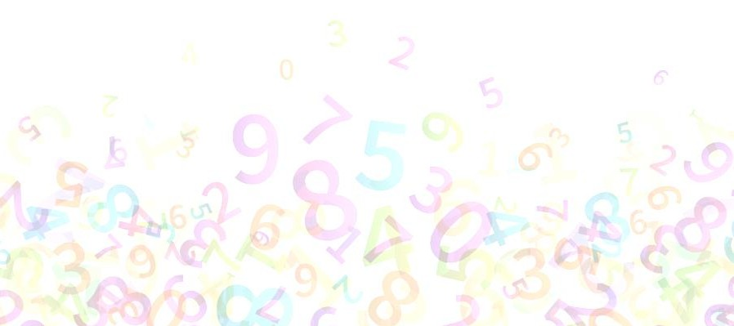
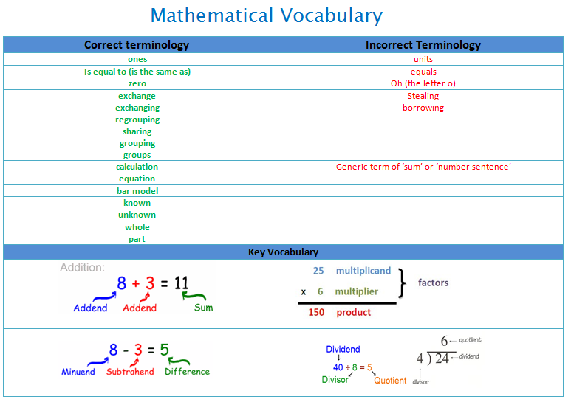


Addend: Any of the numbers that are added together.

Sum: The result of adding two or more numbers

Minuend: The first number in a subtraction. The number from which another number is subtracted.
Subtrahend: The number that is to be subtracted. The second number in a subtraction.

Difference: The result of subtracting one number from another. How much one number differs from another.

Division: Division is splitting into equal parts or groups.

Dividend: The amount that you want to divide up.

Divisor: The number you divide by.

Quotient: The answer after you divide one number by another.
Multiplicand: The number that gets multiplied/ the size of the group.
Multiplier: The number that you are multiplying by/ the number of groups.

Product: The answer when two or more numbers are multiplied together.



Addition  Reception | Concrete | Pictorial | Abstract
Have a deep understanding of number to 10, including the composition of each number.  Subitise (recognise quantities without counting) to 5.  Verbally count beyond 20, recognising the pattern of the counting system.  Compare quantities up to 10 in different contexts, recognising when one quantity is greater than, less than or the same as the other quantity.  Automatically recall (without reference to rhymes, counting or other aids) number bonds up to 5 (including subtraction facts) and some number bonds to 10, including double facts. | 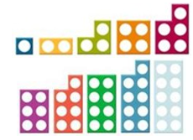  Describing patterns of odd and even. | Using objects and bar models to answer questions like: How many more to make five?  .  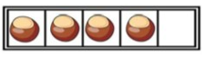

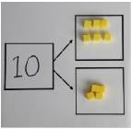
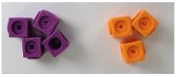
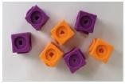
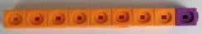
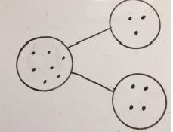






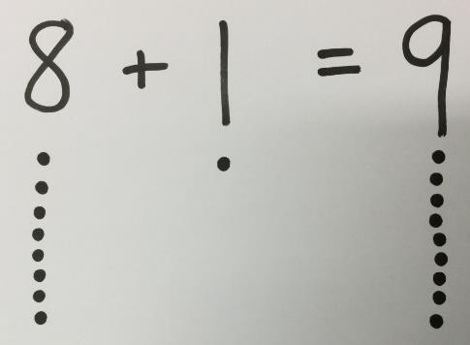
Addition  Year 1 | Concrete |  | Pictorial | Abstract
Combining two parts to make a whole: part – whole model |  |  |  | 6  4  6 + 4 =  = 6 + 4  Use the part-part whole diagram to move into the abstract.
 |  | Use cubes and | Use pictures to add  two numbers together  as group or in a bar.
 |  | diennes to add two
 |  | numbers together
 |  | either as a group,
 |  | part-part-whole
 | 10 = 6 + 4 | diagram or as a bar.  8 + 1 = 9 | 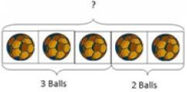
 |  |  | 

Starting at the bigger number and counting on | 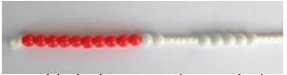  Start with the larger number and count on the smaller number in one by one to find the answer. | 12 + 5 = 17  Start at the larger number on the number and count on in ones or in one jump to find the answer.  A bar model which encourages children to count on rather than count all. | 12 + 5 = 17  Place the larger number in your head and count on the smaller number to find your answer.  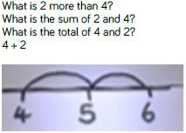  Use a blank number line to count on.
Regrouping to make 10  This is an essential skill for column addition later. | 9 + 3 = 12  Start with the bigger number and use the smaller number to make 10.  Use ten frames, bead strings counters/cubes or Numicon. | 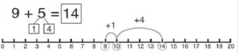  Use pictures or a number line. Regroup or partition the smaller number to make 10 3 + 9 = 12  Children to fill in a ten frame with pencils, counters or cubes. | 7 + 4 = 11  If I am seven how many more do I need to make 10? How many more many more do I add on now?  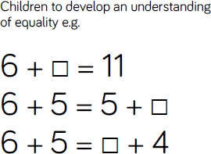
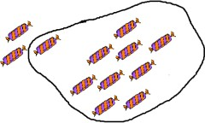
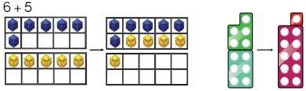


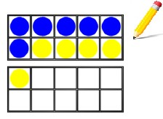
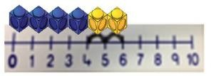
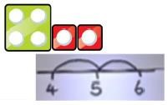
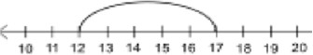
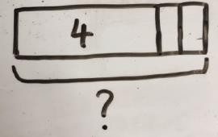
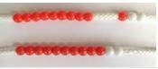

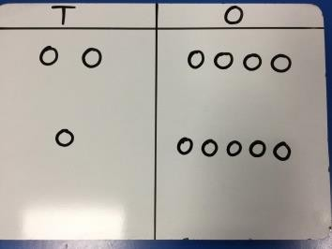
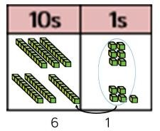
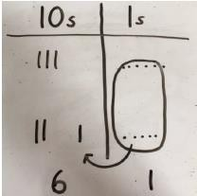
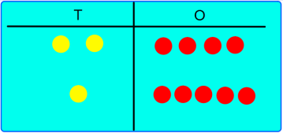
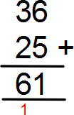


Addition  Year 2 | Concrete |  | Pictorial | Abstract
Add a two digit number and  ones. | Continue to develop understanding of partitioning and place value. |  | 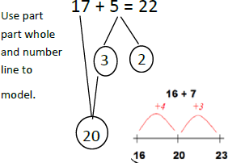  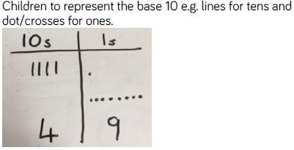 | 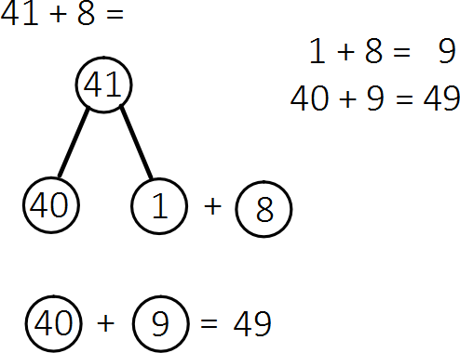
Add TO + O | 41 + 8
 | 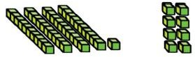
Add two, two digit numbers TO + TO | 36 + 25 = | TO + TO using base 10 first before moving onto place value counters. | After practically using the resources, children to represent  the base 10 in a place | 36 + 25 =  Children to apply their  Understanding from their  use of concrete and  pictorial methods to answer questions using a formal column written method.
 |  | Continue to develop | value chart.
 |  | understanding of  partitioning and | 36 + 25 =
 |  | place value.
 |  |  | Children can draw
 |  |  | the counters in a
 |  | 24 + 15 = | place grid to help  then solve additions

 |  | Use a number line to support bridging ten.  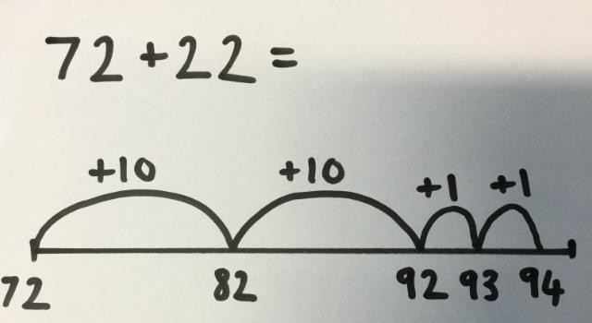 | 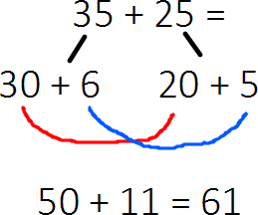
Add a two digit number and tens | 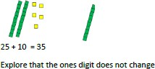 | 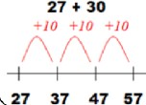 | 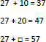
Add three one digit numbers | 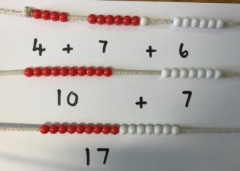  4 + 7 + 6 = 17  Put the 4 and 6 together to make 10. Add on the 7. | 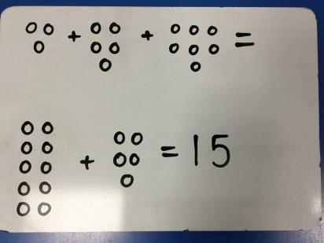  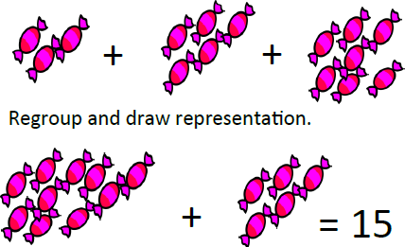 | 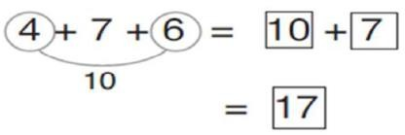  Combine the two numbers that make/bridge ten then add on the third.

Using the inverse to find the missing number.  Difference | 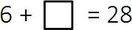  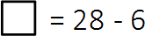  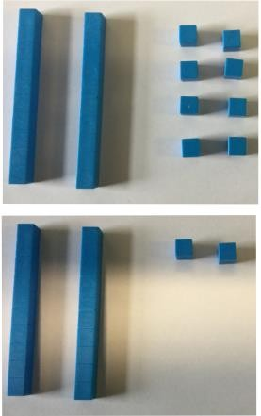 | 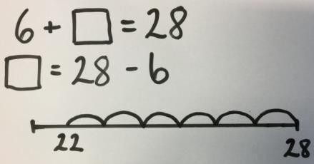  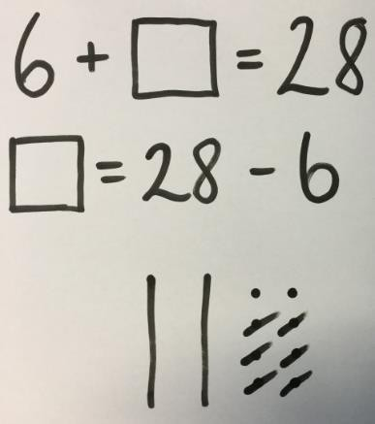  Bar Model:  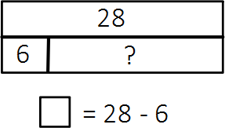 | 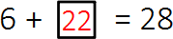  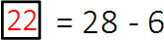



Addition  Year 3 | Concrete | Pictorial | Abstract
Column addition with no regrouping  Numbers up to three digits. | 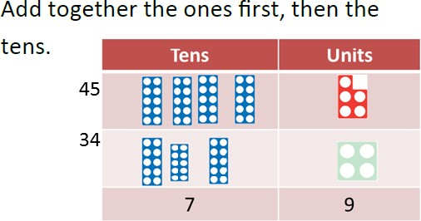  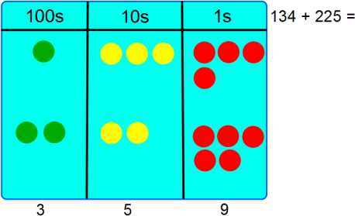 | 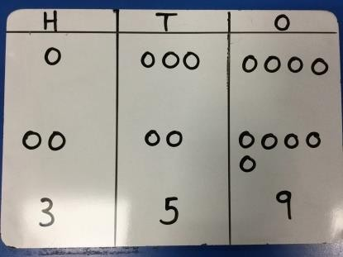 | 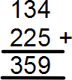
Column addition with regrouping  Numbers up to three digits. | When there are 10 ones in the 1s column we regroup for 1 ten, when there are 10 tens in the 10s column we regroup for 1 hundred.  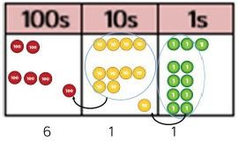 | Children to represent the counters in a place value chart circling when they regroup.  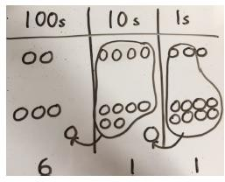 | 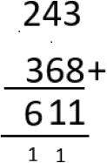

Measure:

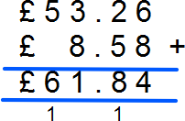



Addition Year  4, 5 and 6 | Concrete | Pictorial | Abstract
Year 4: Column method regrouping (up to 4 digits) | When there are 10 ones in the 1s column we regroup for 1 ten, when there are 10 tens in the 10s column we regroup for 1 hundred. When there are 10 hundreds in the 100s column we regroup for 1 thousand.  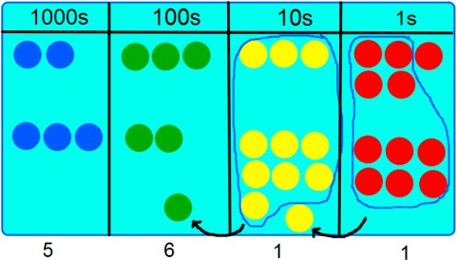 | 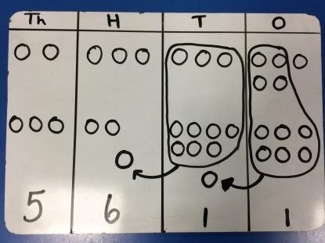 | 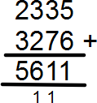
Year 5: Column method regrouping (with more than 4 digits)  Add decimals with 2 decimal places, including money | As year 4, including numbers with more than 4 digits.  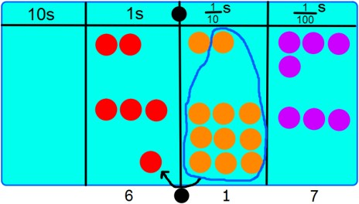  When there are 10 tenths in the 1/10s column we regroup 10 tenths for 1 one, when there are 10 tens in the 10s column we regroup for 1 hundred. When there are 10 hundreds in the 100s column we regroup for 1 thousand. | 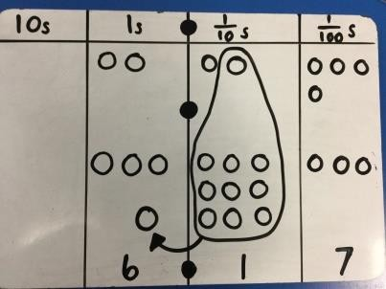 | 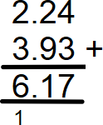  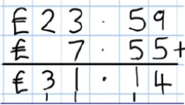

Year 6:  Add several numbers with increasing complexity.  Including adding money, measure and decimals with different decimal points. | Use place value counters as above if still necessary. | Use jottings as above if still necessary. | 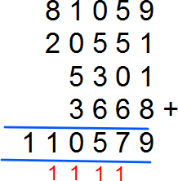  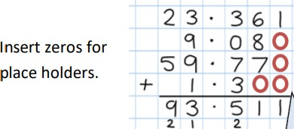
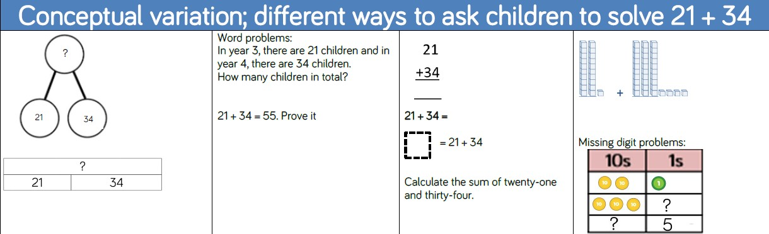




Subtraction  Reception | Concrete | Pictorial | Abstract
Have a deep understanding of number to 10, including the composition of each number.  Subitise (recognise quantities without counting) to 5.  Verbally count beyond 20, recognising the pattern of the counting system.  Compare quantities up to 10 in different contexts, recognising when one quantity is greater than, less than or the same as the other quantity.  Automatically recall (without reference to rhymes, counting or other aids) number bonds up to 5 (including subtraction facts) and some number bonds to 10, including double facts. | 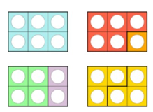  Compose 6 in different ways.  Four bears go camping. How many are in the tent?  



Subtraction  Year 1 | Concrete | Pictorial | Abstract
Taking away ones. | Use physical objects, counters, diennes, cubes etc. to show how objects can be taken away.  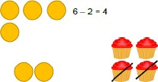 | 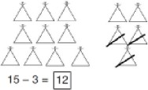  Cross out drawn objects to show what has been taken away.  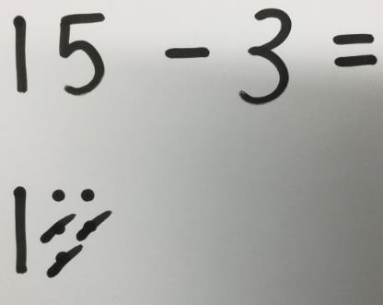 | 7 – 4 = 3  16 – 9 = 7
Counting back. | 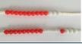  Move the beads along the bead string as you count backwards in ones.  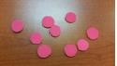  Move objects away from the group, counting backwards | 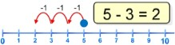  Count back in ones using a number line. | Put 13 in your head, count back 4. What number are you at?

Find the difference | Compare objects and amounts.  Use cubes to build towers or make bars to find the difference  Use basic bar models with items to find the difference. | Count on using a number line to find the difference. +6  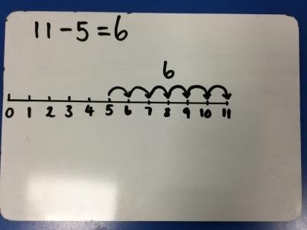  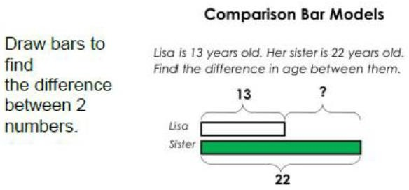 | Hannah has 12 grapes and her sister has 5. How many more does Hannah have than her sister?  Helen has 11 plums and her sister has 3. Find the difference between the number of plums.
Part Part Whole model. | 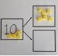  Link to addition. Use PPW model to model the inverse. | Use pictorial representations to show the part. | Move to using numbers within the part part whole model.
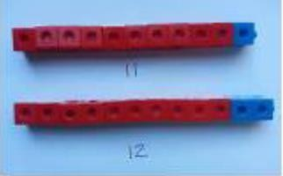
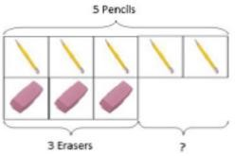
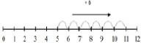

 | If 10 is the whole and 6 is one of the parts, what is the other number?  10 – 6 = 4 | 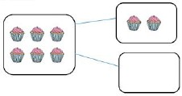 | 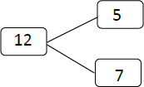
Make 10. | 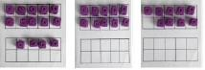  14 – 9 =  Make 14 on the tens frame. Take 4 away to make ten, then take one more away so that you have taken 5. | Jump back 3 first, then another 4. Use ten as the stopping point.  Children must be encouraged to draw a number line and be able to interpret one.  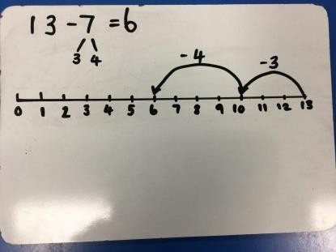 | 16 – 8  How many do we take off first to get to 10? How many left to take off?


28-6=

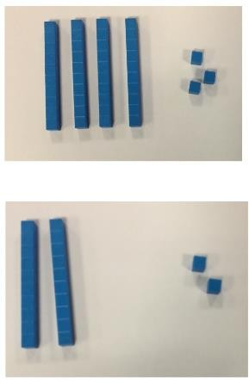
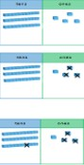


Subtraction  Year 2 | Concrete | Pictorial | Abstract
Regroup a ten into ten ones. | 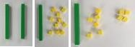  20 – 4 = 16  Change a ten into ten ones. | 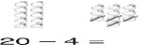 | 20 – 4 = 16
Subtracting without regrouping. | 43-21 = 22  Use Dienes to show how to partition the number when subtracting without regrouping.  34 – 13 = 21 | 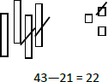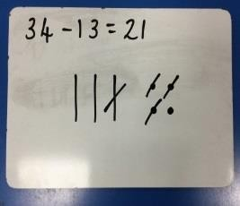  Children draw representations of Dienes and cross off.  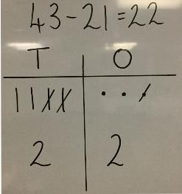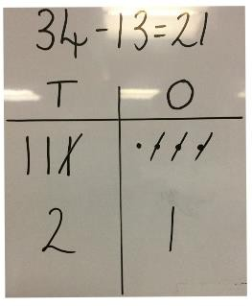 | Children to be supported in their understanding by using a formal column method.  43 – 21 = 22  34 – 13 = 21  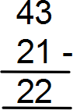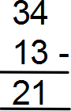

Subtracting TO –TO with regrouping | 42 – 24 = 18  Start with the ones, can I take away 2 from 2 ones easily? No, I need to exchange one of my tens for ten ones.  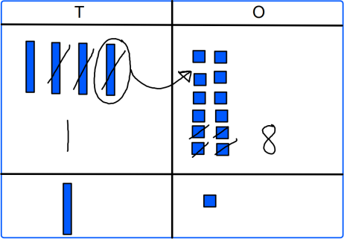  Now I can subtract my ones (remove/cross out cubes from the place value mat).  Now look at the tens, can I take away 2 tens from the 3 tens easily? Yes. | 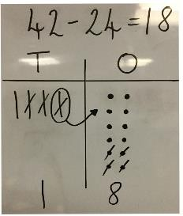 | 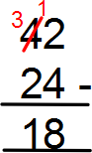
Make ten strategy.  Progression should be crossing one ten, crossing more than one ten, crossing the hundreds. | 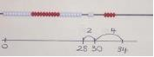  34 – 28 =  Use a bead bar or bead strings to model counting to next ten and the rest. | 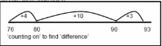  Use a number line to count on to the next ten and then the rest.  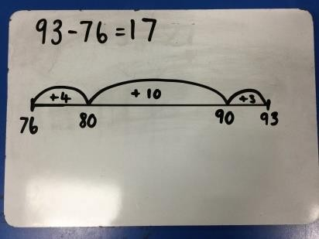 | 93 – 76 =

Bar Model:

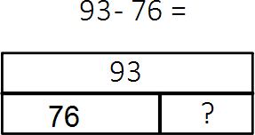

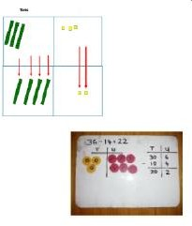


Subtraction  Year 3 | Concrete | Pictorial | Abstract
Column subtraction without regrouping. | 75 – 42 =  Use Base 10 to make the bigger number then take the smaller number away.  Show how you partition numbers to subtract.  Again make the larger number first. | 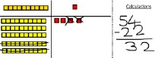  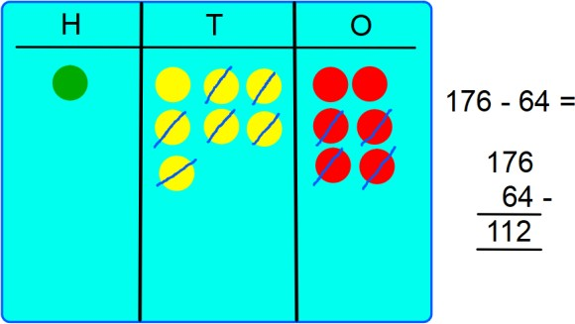  Draw the base 10 or place value counters alongside the written calculation to help show working.  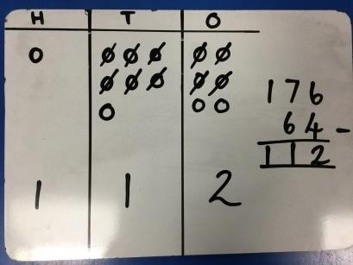  Children could rub out jottings instead of crossing them out. | 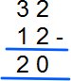  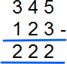

Column subtraction with regrouping. | Use base 10 to start with before moving onto place value counters. Start with one exchange before moving onto subtractions with 2 exchanges.  Make the larger number with the place value counters.  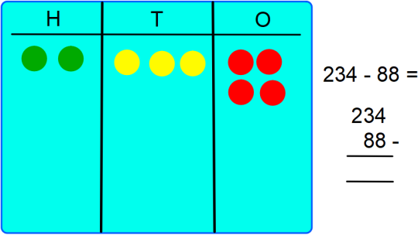  Start with the ones, can I take away 8 from 4 easily? I need to exchange one of my tens for ten ones.  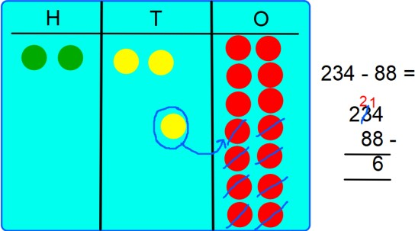  Now I can subtract my ones (remove counters from the place value mat).  Now look at the tens, can I take away 8 from the tens easily? I need to exchange one hundred for  ten tens. | 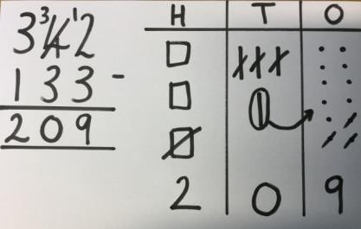  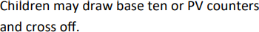  Draw the counters onto a place value grid and show what you have taken away by crossing out or rubbing out as well as clearly showing the exchanges you make. | 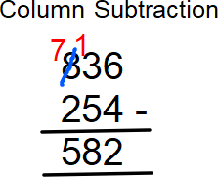  Measure:  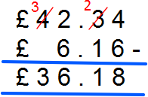
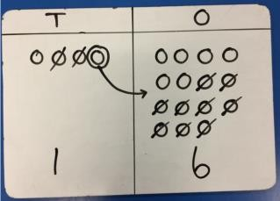

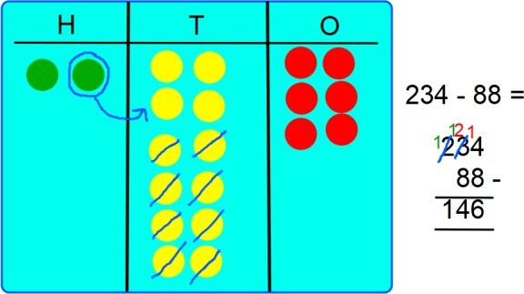
Now I can take away eight tens and complete my subtraction.

Show the children how the concrete method links to the written method alongside your working. Cross out the numbers when exchanging and show where we write our new amount.



Subtraction Year 4, 5 and  6 | Concrete | Pictorial | Abstract
Year 4 to subtract with up to 4 digits.  Introduce decimal subtraction through context of money. | 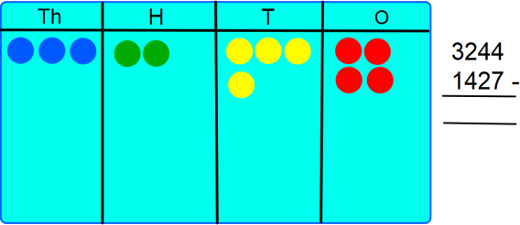  Start with the ones, can I take away 7 from 4 ones easily? I need to exchange one of my tens for ten ones.  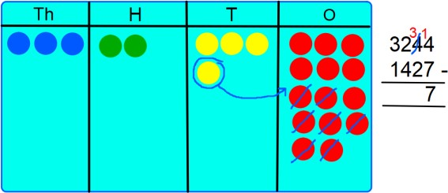  Now I can subtract my ones (remove counters from the place value mat).  Now look at the tens, can I take away 2 tens from the 3 tens easily? Yes. | 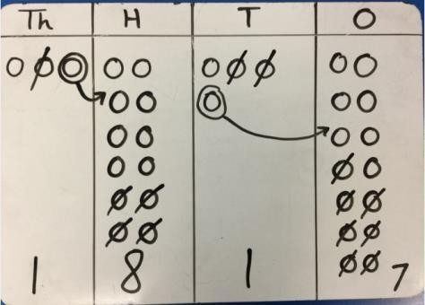 | 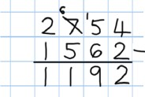

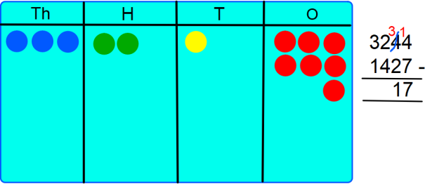
Now look at the hundreds, can I take away 4 hundred from 2 hundred? I need to exchange one of my thousands for 10 hundreds.
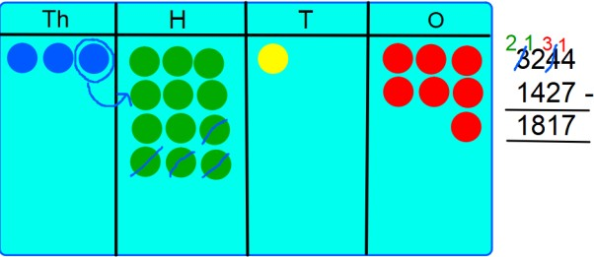
Now I can complete my calculation.
Year 5 –  Subtract with at least 4 digits, including money and measures. | See Year 4. | See Year 4. | 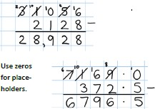

Year 6 – Subtract with increasingly large and more complex numbers and decimal values. |  |  | 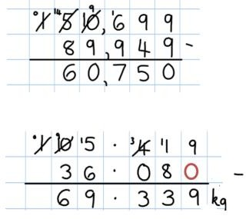
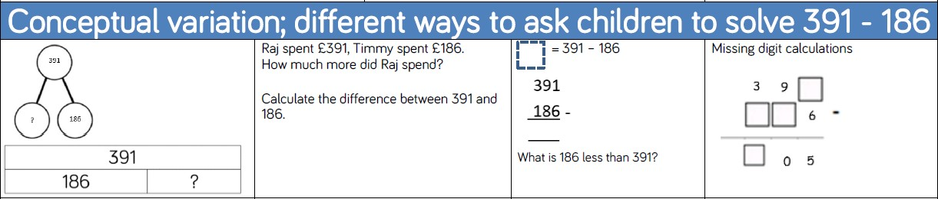



Multiplication  Reception | Concrete | Pictorial | Abstract
Subitise (recognise quantities without counting) to 5.  Verbally count beyond 20, recognising the pattern of the counting system.  Compare quantities up to 10 in different contexts, recognising when one quantity is greater than, less than or the same as the other quantity.  Explore and represent patterns within numbers up to 10, including evens and odds, double facts and how quantities can be distributed equally | 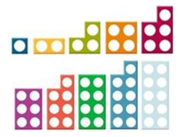  Describing the patterns of odd and even.  ‘Doubling up’ using familiar representations.  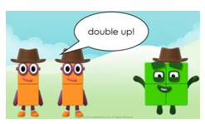  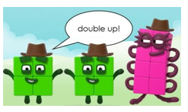



Multiplication  Year 1 | Concrete | Pictorial | Abstract
Doubling | Use practical activities using manipulatives including cubes and Numicon to demonstrate doubling.  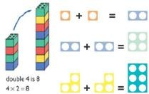 | Draw pictures to show how to double numbers.  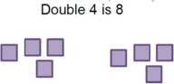  Children make representations to show counting in multiples. | Draw pictures to show how to double numbers.  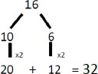
Counting in multiples  /repeating groups | 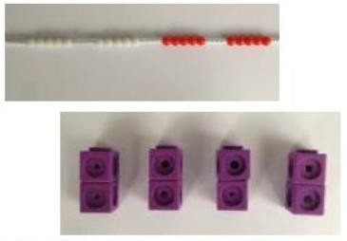  Count in multiples supported by concrete objects in equal groups. |   Children make representations to show counting in multiples.  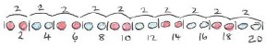  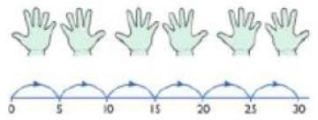  Use a number line or pictures to continue support in counting in multiples. | Count in multiples of a number aloud.  Write sequences with multiples of numbers.  2, 4, 6, 8, 10  5, 10, 15, 20, 24, 30

Repeated addition | 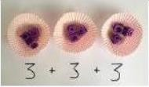  Use different objects to add equal groups.   | There are 3 plates. Each plate has 2 star biscuits on. How many biscuits are there?  2 add 2 add 2 equals 6    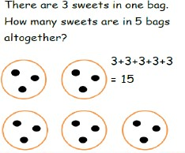  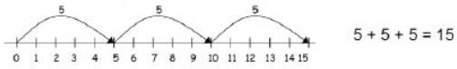  Use pictorial including number lines to solve problems.  Children could represent the practical resources in a picture or use a bar model. | Write addition sentences to describe objects and pictures.  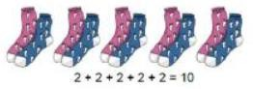
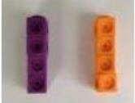
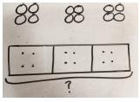

Understanding arrays | Create arrays using counters/cubes/  dienes/ base 10 to show multiplication sentences. | Children to represent the arrays pictorially to show their understanding.  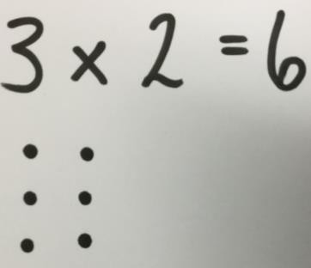 | 3 x 2 = 6  2 x 5 = 10
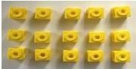
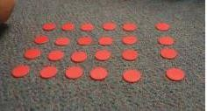

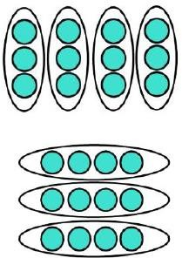


Multiplication  Year 2 | Concrete | Pictorial | Abstract
Arrays showing commutivity | 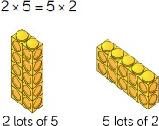  Pupils should understand that an array can represent different equations and that, as multiplication is commutative, the order of multiplication does not affect the answer.  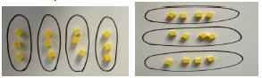 | 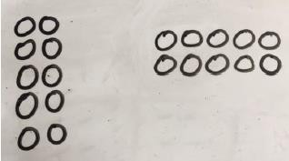  Use representations of arrays to show different calculations and explore commutativity.  . | 12 = 3 x 4  12 = 4 x 3  Use an array to write multiplication sentences and reinforce repeated addition.  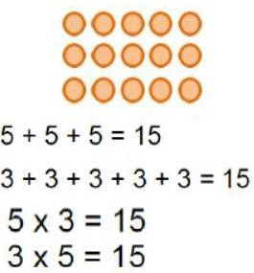

Doubling | Model doubling using dienes and place value counters. Eg. 26 x 2 =  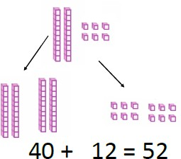 | Draw pictures and representations to show how to double numbers.  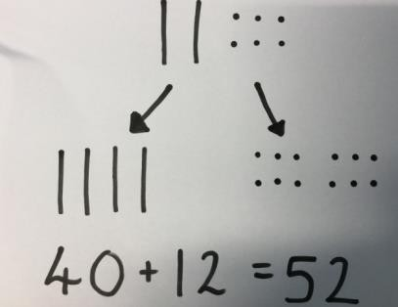 | Partition a number and then double each part before recombining it back together  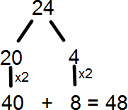
Counting in multiples of 2,  3, 5, 10  from 0 | Count the groups as children are counting in the multiples. You could use bar models.  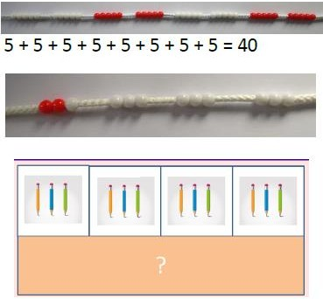  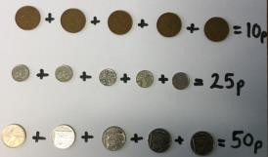 | Number lines, counting sticks and bar models should be used to show representation of counting in multiples.  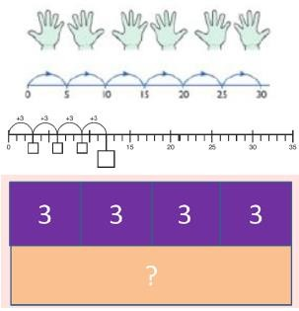 | Count in multiples of a number aloud.  Write sequences with multiples of numbers.  0, 2, 4, 6, 8, 10  0, 3, 6, 9, 12, 15  0, 5, 10, 15, 20, 25, 30  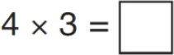

Using the inverse  This should be taught alongside division, so pupils learn how they work alongside each other. | 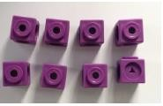 | 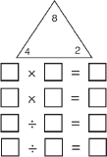 | 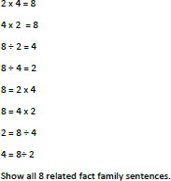

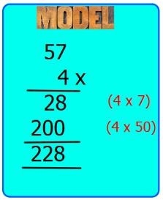
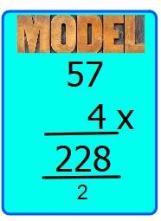


Multiplication  Year 3 | Concrete | Pictorial | Abstract
Grid method | Show the links with arrays first to introduce the grid method.  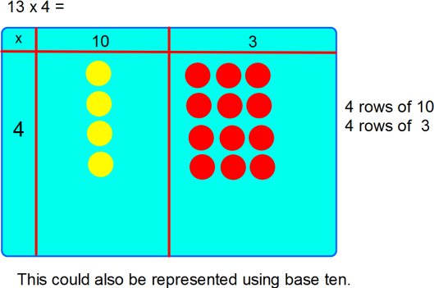  Move onto place value counters to show how we are finding groups of a number.  We are multiplying by 4 so we need 4 rows.  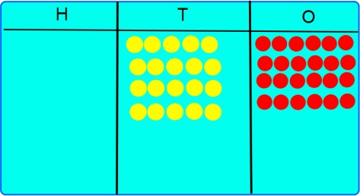 | 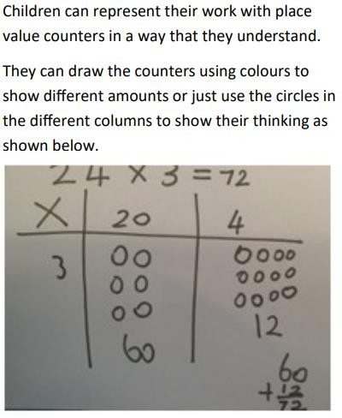 | 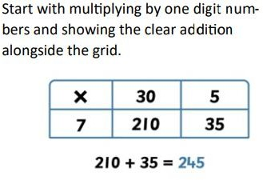  If appropriate, NC states that Year 3 should be introduced to a formal written method of short multiplication (TO x O).  Expanded Multiplication:  The children could move onto using short multiplication for TO x O

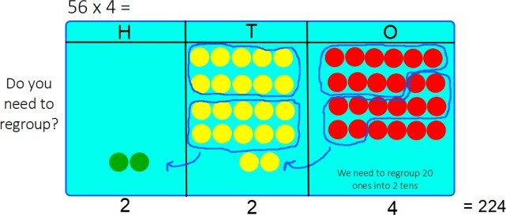

We need to regroup 2 tens into 2 hundreds



Multiplication Year 4, 5 and  6 | Concrete | Pictorial | Abstract
Year 4:  Review grid method moving on to 3 digit numbers by 1 digit if children require visual partitioning of digits. | Move onto place value counters to show how we are finding groups of a number.  136 x 4 = We are multiplying by 4 so we need 4 rows.  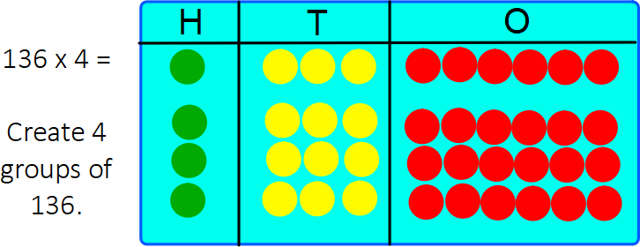  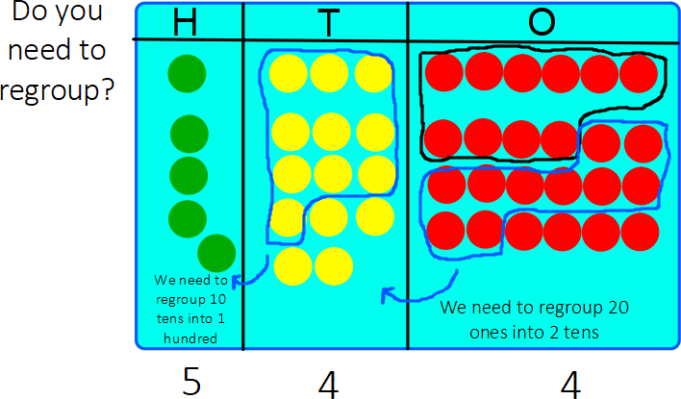  Add up each column, starting with the ones regrouping where needed. | 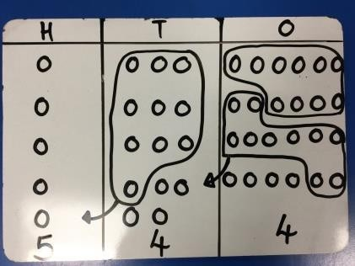 | 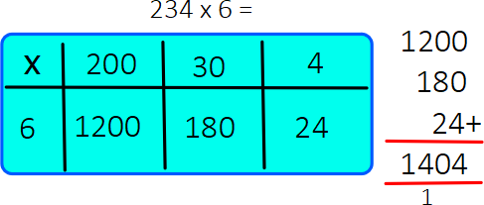

Year 4:  Short Multiplication  Numbers up to 3 digits. | Children can continue to be supported by place value counters at this stage of multiplication.  See above. | The grid method may be used to show how this relates to a formal written method.  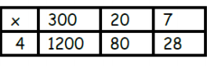 | 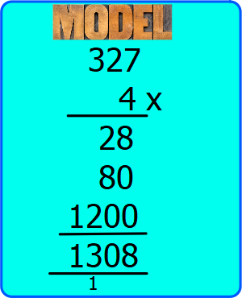  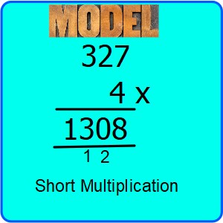
Year 5 and  Year 6  ThHTO x O  ThHTO x TO | Children can continue to be supported by place value counters if necessary. | See above. | 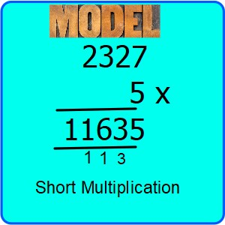

 |  | When children start to multiply 3 digit by 3 digit and 4 digit by 2 digit etc., they should be confident with the abstract. | In year 5, children are expected to be able to use long multiplication for two digit numbers.  Start with long multiplication, reminding the children about lining up their numbers clearly in columns.  If it helps, children can write out what they are solving next to their answer.  In Year 6, children are expected to multiply multi- digit numbers up to 4 digits by a two-digit whole number using the formal written method of long multiplication.
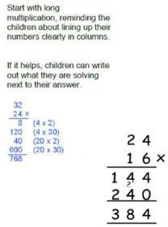

 |  |  | 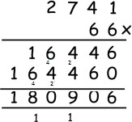
Year 6: |  |  | Children are required to multiply one-digit numbers with up to two decimal places by whole numbers (NC-Fractions including decimals)  Remind children that the single digit belongs in the ones column. Line up the decimal points in the question and in the answer.  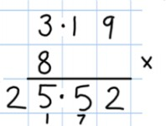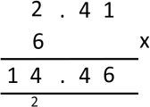
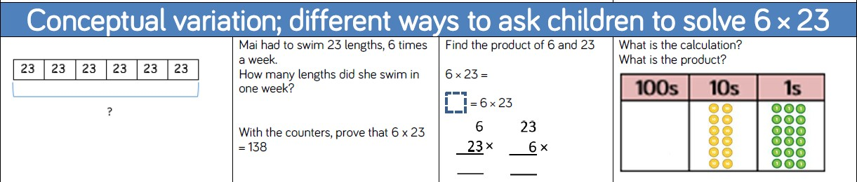



Subtraction  Reception | Concrete | Pictorial | Abstract
Subitise (recognise quantities without counting) to 5.  Verbally count beyond 20, recognising the pattern of the counting system.  Compare quantities up to 10 in different contexts, recognising when one quantity is greater than, less than or the same as the other quantity.  Explore and represent patterns within numbers up to 10, including evens and odds, double facts and how quantities can be distributed equally. | Describing patterns of odd and even.  Six sweets shared equally between three friends.  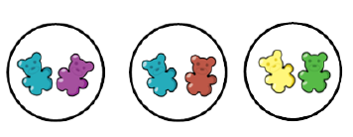



Division Year 1 | Concrete | Pictorial | Abstract
Sharing objects into groups  Division as grouping | Sharing:  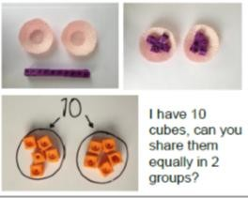  Grouping:  I have 10 cubes. Can you group them into 2s?  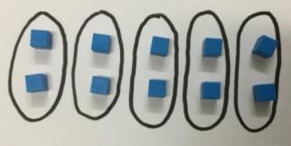 | Sharing:  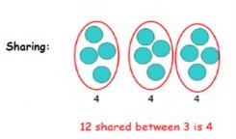  Grouping:  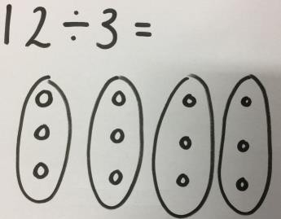  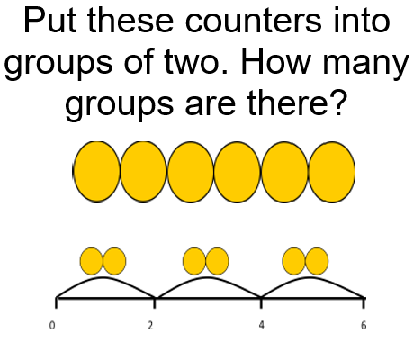 | Sharing:  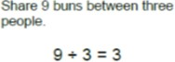  Grouping:  Divide 15 into groups of 5. How many groups are there?



Division  Year 2 | Concrete | Pictorial | Abstract
Division as sharing and grouping | Sharing:    12 ÷ 3 = 4  Grouping:  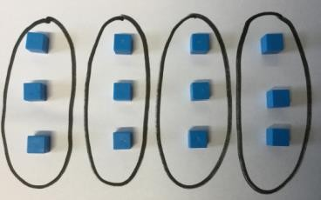  12 ÷ 3 = 4  Using Arrays:  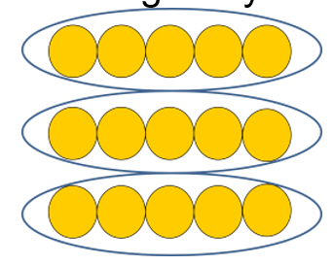15 ÷ 3 = 4 | Sharing:  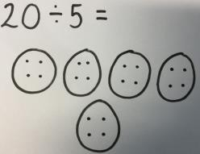  Bar Model:  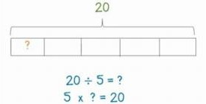  Think of the bar as a whole. Split it into the number of groups you are dividing by and work out how many would be within each group. | Sharing:  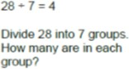  Grouping:  Divide 28 into groups of 7. How many groups are there?

Grouping:

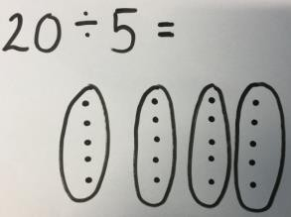

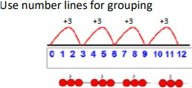

12 ÷ 3 = 4



Division  Year 3 | Concrete | Pictorial | Abstract
Division with arrays | 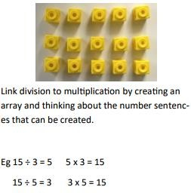 | 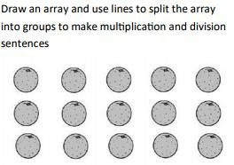 | 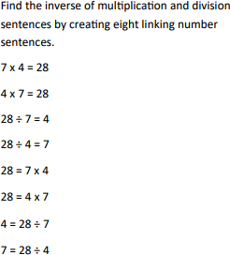

Division with and without remainders | 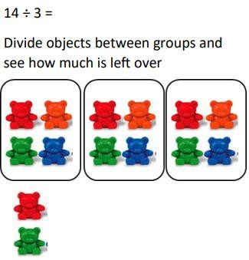  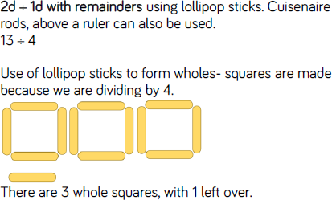 | 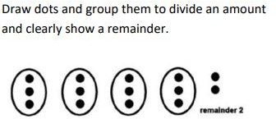  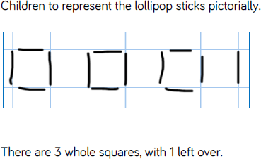 | 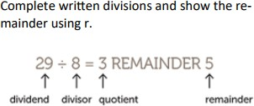  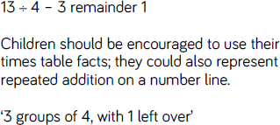

Introducing Short division (no remainders)  Grouping with place value counters  (no regrouping) | Use place value counters to introduce dividing using short division. Where appropriate children to record their response in the short division method.  63 ÷ 3 =  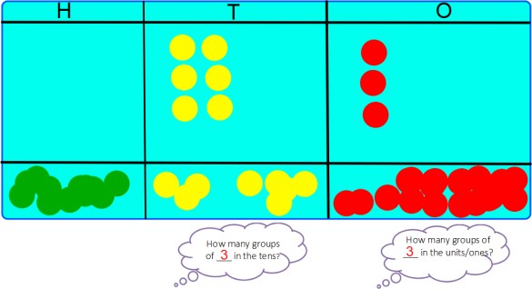  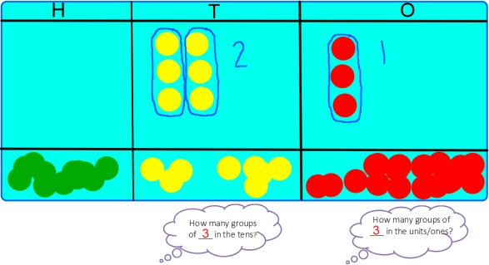  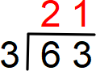 | 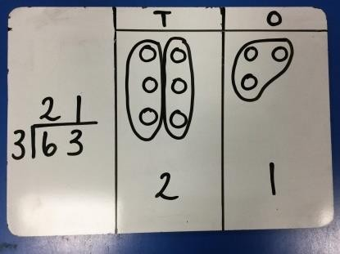 | 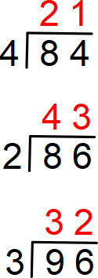

Introducing Short division  Grouping with place value counters  (regrouping) | 96 ÷ 8 =  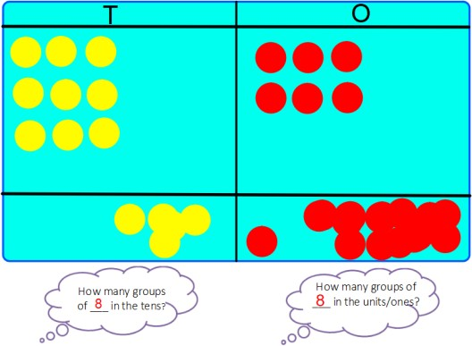  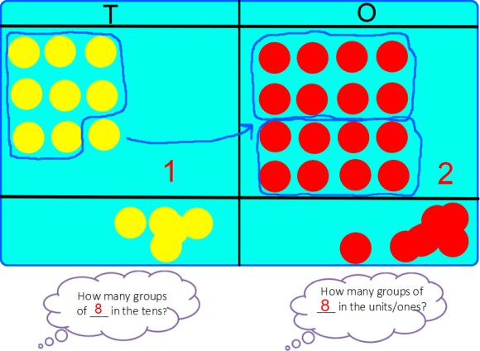  We need to exchange 1 ten from the tens into 10 ones. | 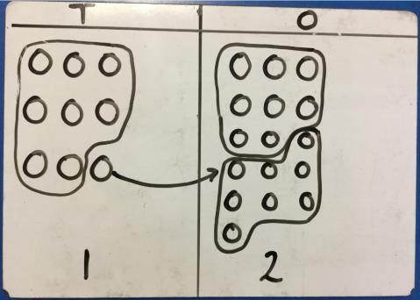  Encourage the children to record their answer in the short division format. | 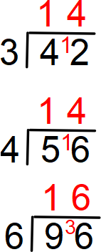
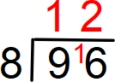

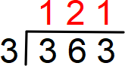


Division Year 4, 5  and 6 | Concrete | Pictorial | Abstract
Divide at least 3 digit numbers by 1 digit.  (no regrouping)  Short Division | Use place value counters to introduce dividing 3 digit numbers using short division. Alongside using the place value counters, children need to record their answer in short division  363 ÷ 3 =  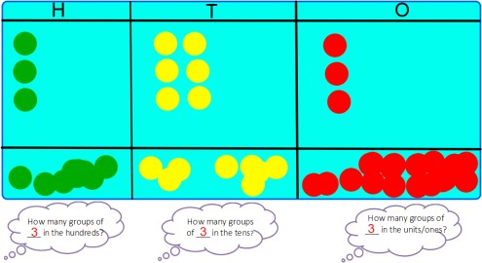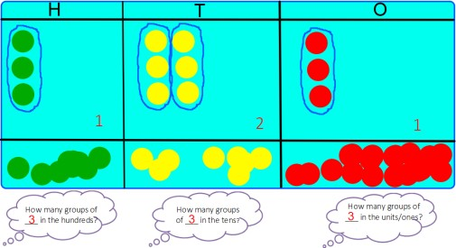  363 ÷ 3 = 121 | Encourage the children to record their answer in the short division format.  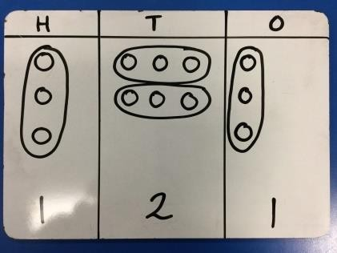 | 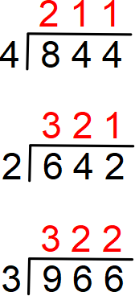

Divide at least 3 digit numbers by 1 digit. (regrouping)  Short Division | 615 ÷ 5 =  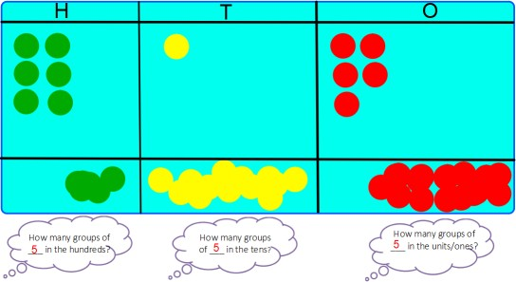  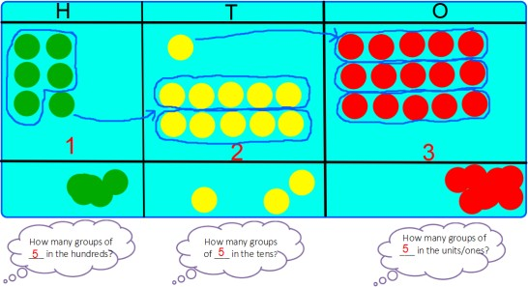  Encourage the children to record their short division calculation alongside their use of place value counters. | 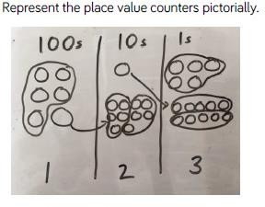  Encourage the children to record their answer in the short division format. | 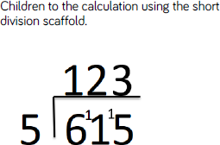

Year 5 and 6  Short Division:  Divide at least 4 digit numbers by 1 digit. (regrouping)  Divide numbers up to 4 digits by a two- digit number using the formal written method of short division  Short Division | 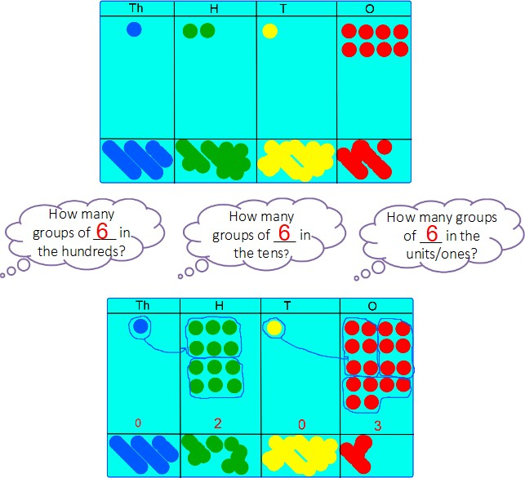  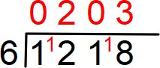 | 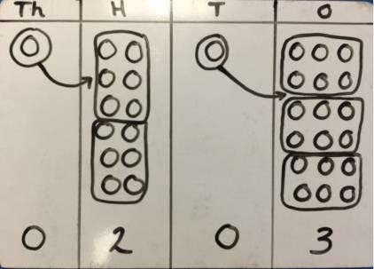  Encourage the children to record their answer in the short division format. | 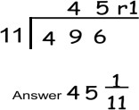

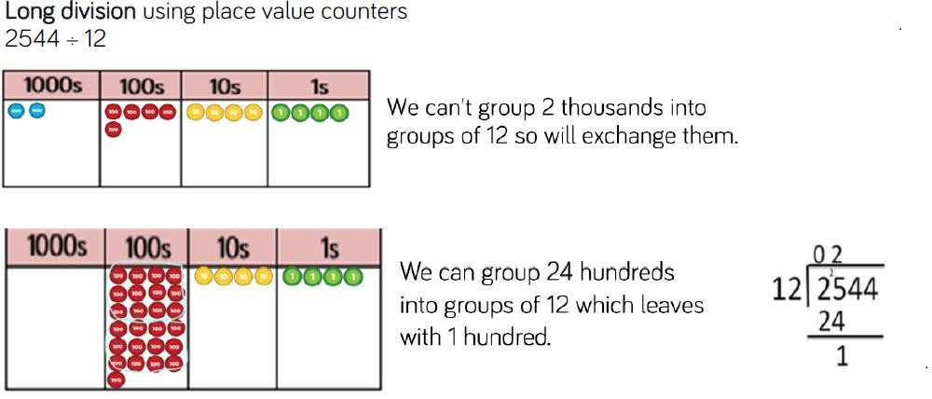
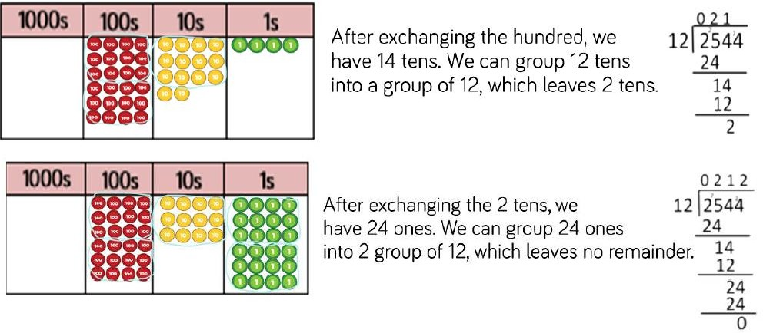

Year 6
Long division:
Divide numbers up to 4 digits by a 2 digit whole number using the formal method of long division, and interpret remainders as whole number remainders, fractions or by rounding, as appropriate for context.

Long division using ratio charts | 

